**Install Rust and Cargo**

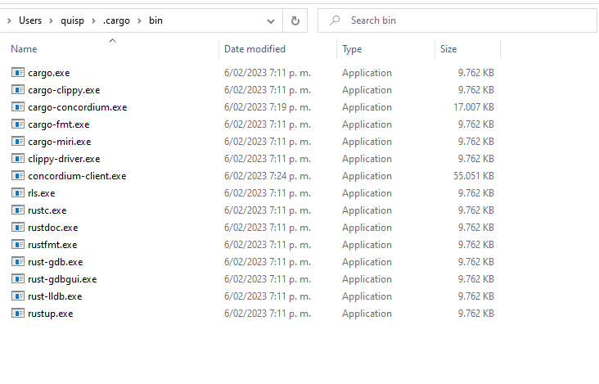

*cargo concordium --help*

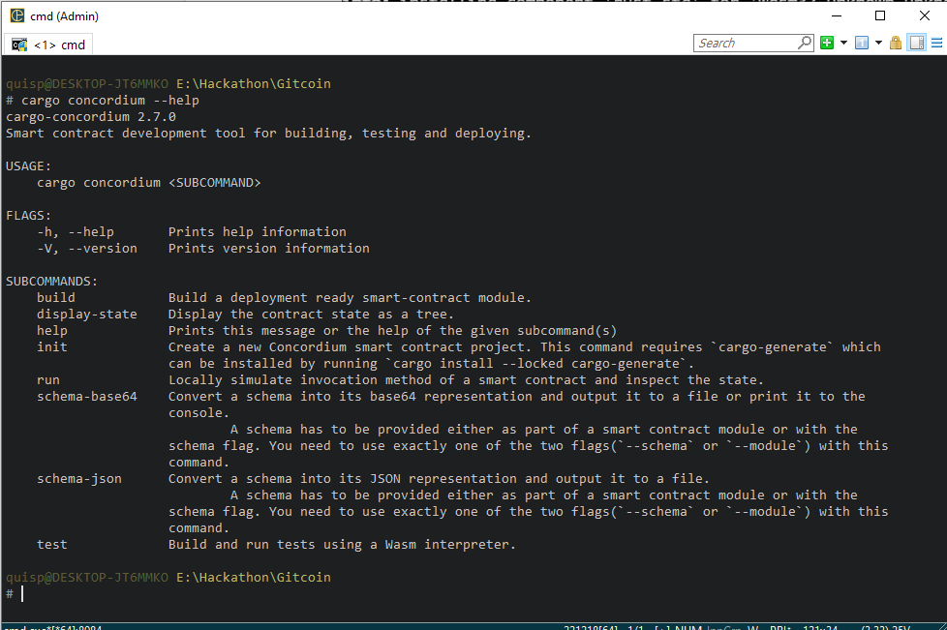

*concordium-client –help*

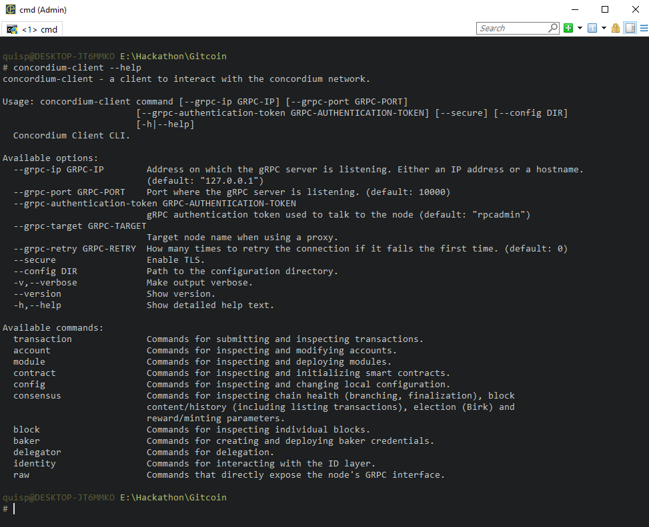

**Connect to the public node**

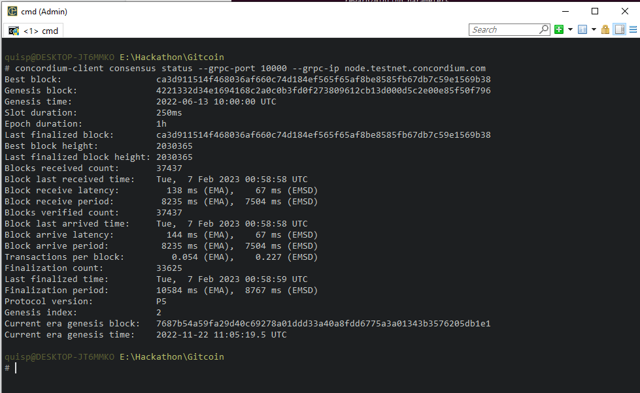

**Concordium Wallet - Testnet**:

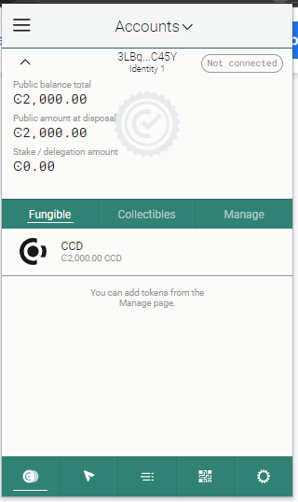

**Import the key**

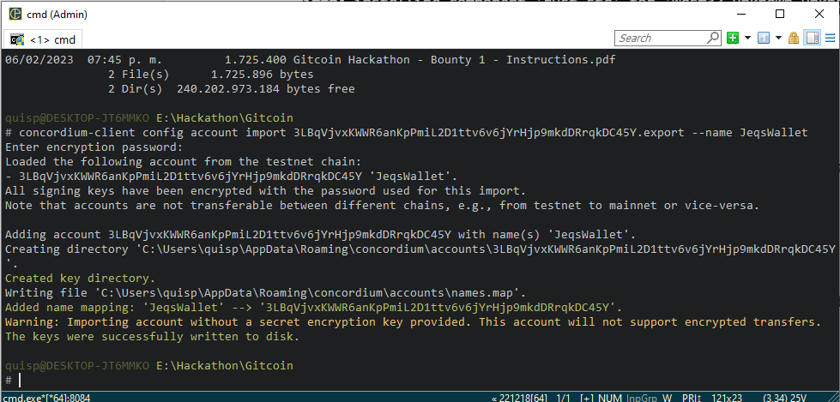

**Concordium Wallet - Mainnet**:

3Z2PrTLoBuum5gNn1TgY19uvjsF91CenFtVqaoLZ2xMMo27htr

